Title of the paper
Author 1 (e.g. A. Smith)¹, Author 2¹, Author 3², …
¹Dept., Name of organization, (acronym), City, Country. E-mail address if desired (if several authors from the same affiliation, separate e-mail addresses with a semicolon)
²Dept., Name of organization, (acronym), City, Country. E-mail address if desired

Abstract – Provide an abstract of your paper in max. 150 words. Do not include any figure, table or equation in this section.
Keywords – Provide max. 5 keywords that accurately describe your work with a semicolon separating them

Instructions (ERASE THIS SECTION)

General
This template, saved as a ‘Word 97-2003 Document’ for PC, provides authors with the formatting specifications needed for preparing electronic versions of their papers for the EECHB 2016 Conference. Once these instructions are clear, the sample elements of the document should be replaced with relevant text regarding the paper submitted to EECHB 2016. An example of what the output paper should look like is available as pdf-file (‘Template_EECHB_example.pdf’, downloadable on www.eechb.eu).
This Word template has been tailored for output on A4 paper size. The maximum number of pages allowed is seven, including graphics, tables, cover page, and references. The paper should be written in proper UK-English. It can be uploaded in .doc or .docx format and the deadline for submission is Sunday 21st February 2016, before midnight. Margins, line spacing, and style types are built-in; please use built-in styles and DO NOT ALTER THEM. Styles are mentioned throughout this document and are identified in italics between quotation marks.
The author should try to provide a simple and clear structured text, ideally with no more than three heading sublevels (levels x → x.x.x). The text should include: an introduction section, the presentation of the followed methodology and the equipment/materials used, the presentation and discussion of results, some conclusions, and references. For paragraphs, use ‘EECHB Normal’ style: Times New Roman 12 point size and 15 point line spacing. Do not use bold, except to denote vectors in mathematics. Do not underline any text. Do not use letter spacing and do not use more than one space after each other.

Figures and tables
For figures, use 300 dpi resolution (at least) TIFF or EPS file with all fonts embedded. Apply ‘EECHB Figure’ style on each figure. Avoid figures that are too large or too small. Avoid placing text between figures as readers might not notice the text. Use consistent font size within the text of figures.
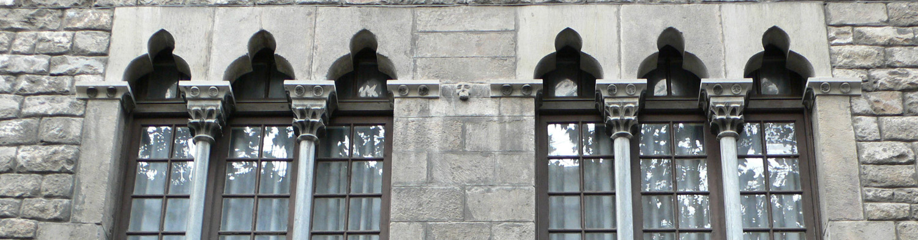
Figure 1. Example of Figure
Table should be centred. Use ‘EECHB Table Text’ style for table data. Italics or bold characters can be used to highlight the heads of lines and columns. All cells should be centred. Table 1 shows an example of acceptable table.
Table 1. Example of Table
Table Head | Table column head
Table Head | Table column subhead | Subhead | Subhead
Line head | Data | … | …
Number figures and tables consecutively in the order in which reference is made to them in the text, making no distinction between diagrams and photographs. Figure captions should be below the figures; table captions should appear above the tables. Insert figures and tables after they are cited in the text. Use ‘EECHB Caption Figure’ or ‘EECHB Caption Table’ styles for captions, respectively for figures and tables. Use the abbreviations “Fig. 1” and “Table 1”, even at the beginning of a sentence.

Equations
The equations are an exception to the prescribed specifications of this template. You will need to determine whether or not your equation should be typed using either the Times New Roman font, the Symbol font, or the Cambria Math font (no other font). To create multileveled equations, it may be necessary to treat the equation as a graphic and insert it into the text after your paper is styled.
Number equations consecutively. Equation numbers, within parentheses, are to position flush right, as in (1), using a right tab stop. To make your equations more compact, you may use the solidus (/), the exp function, or appropriate exponents. Use a long dash rather than a hyphen for a minus sign. Punctuate equations with commas or periods when they are part of a sentence.
(1)
Note that the equation is centred using a centre tab stop. Be sure that the symbols in your equation have been defined before or immediately following the equation. Use “(1),” not “Eq. (1)” or “equation (1),” except at the beginning of a sentence: “Equation (1) is ...”
Note: For the subscript of common scientific constants, such as μ₀, use a subscript formatting, not a lowercase character.

Abbreviations and acronyms
Define abbreviations and acronyms the first time they are used in the text, even after they have been defined in the abstract. Abbreviations such as IEEE, SI, MKS, CGS, sc, dc, and rms do not have to be defined. Do not use abbreviations in the title or heads unless they are unavoidable.
Here are some general rules:
- 0.50 instead of 0,50 (used in French text); 9000 instead of 9,000 but if more than 10,000: 10,000 instead of 10000 (and 10,000.57 instead of 10000,57)
- Use SI units (MKS): kg, m, kJ, cm³, J/(kg.K), etc.
- Do not mix complete spellings and abbreviations of units: ‘Wb/m²’ or ‘webers per square meter,’ not ‘webers/m²’. Spell units when they appear in text: ‘...a few henries,’ not ‘...a few H.’
- ¹⁴C instead of C14 / C-14 and BP / BC / AD instead of B.P. / B.C. / A.D.
- × 20 instead of ×20 / X20 / x 20; 4 + 5 > 7 instead of 4+5>7 but –8 / +8 instead of – 8 / + 8
- e.g. / i.e. instead of e.g., / i.e.,

Referencing sources
The IEEE citation style is used. Table 2 and Table 3 provide formatting rules. When referring to a reference in the text, put the number of the reference in square brackets, e.g. [1]. In the last section of the paper, the references should be numbered and appear in the order they appear in the text. The style used for listing bibliographic elements is ‘EECHB Reflist’.

Table 2. Style for references: print references
Table 3. Style for references: electronic references
Book | Author(s). Book title. Location: Publishing Company, year, pp.
Book Chapters | Author(s). “Chapter title” in Book title, edition, volume. Editors name, Ed. Publishing location: Publishing Company, year, pp.
Article in a Journal | Author(s). “Article title”. Journal title, vol., pp, date.
Articles from Conference Proceedings (published) | Author(s). “Article title.” Conference proceedings, year, pp.
Papers Presented at Conferences (unpublished) | Author(s). “Paper’s title,” Conference name, Location, year.
Book | Author. (year, Month day). Book title. (edition). [Type of medium]. Vol. (issue). Available: site/path/file [date accessed].
Journal | Author. (year, month). “Article title.” Journal title. [Type of medium]. Vol. (issue), pages. Available: site/path/file [date accessed].
WWW | Author(s). “Title.” Internet: complete URL, date updated [date accessed].

Heading level 1
Sample text
…
- List element, level 1
  - List element, level 2
  - …
    - List element, level 3
    - …
  - …
- …
Sample text
- Numbered list element, level 1
  - Numbered list element, level 2
    - Numbered list element, level 3
    - …
  - …
- …

Heading Level 1
Sample text
…

Heading level 2

Heading level 3
Sample text
…

Heading level 3

…

References (Examples)

- W.K. Chen. Linear Networks and Systems. Belmont, CA: Wadsworth, 1993, pp. 123-35.
- J.E. Bourne. “Synthetic structure of industrial plastics,” in Plastics, 2nd ed., vol. 3. J. Peters, Ed. New York: McGraw-Hill, 1964, pp.15-67.
- G. Pevere. “Infrared Nation.” The International Journal of Infrared Design, vol. 33, pp. 56-99, Jan. 1979.
- D.B. Payne and H.G. Gunhold. “Digital sundials and broadband technology,” in Proc. IOOC-ECOC, 1986, pp. 557-998.
- B. Brandli and M. Dick. “Engineering names and concepts,” presented at the 2nd Int. Conf. Engineering Education, Frankfurt, Germany, 1999.
- S. Calmer. (1999, June 1). Engineering and Art. (2nd edition). [On-line]. 27(3). Available: www.enggart.com/examples/students.html [May 21, 2003].
- A. Paul. (1987, Oct.). “Electrical properties of flying machines.” Flying Machines. [Online]. 38(1), pp. 778-998. Available: www.flyingmachjourn/properties/fly.edu [Dec. 1, 2003].
- M. Duncan. “Engineering Concepts on Ice. Internet: www.iceengg.edu/staff.html, Oct. 25, 2000 [Nov. 29, 2003].

See MS Word styles library

